Assignment-1 Salim Ahmad

Q.1 check whether a number entered by user is even or odd.
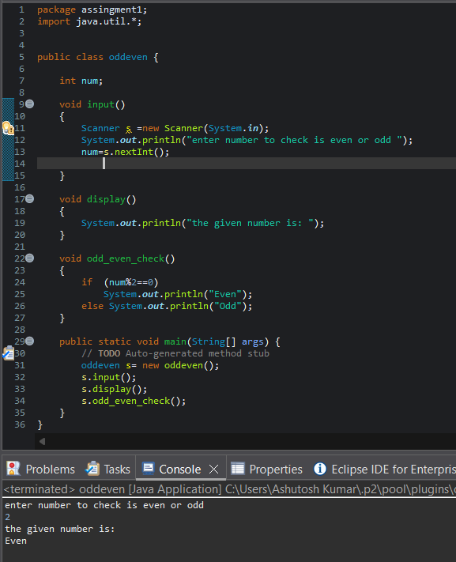

Q.2 Check if a person is eligible to vote (age must be 18 or above).
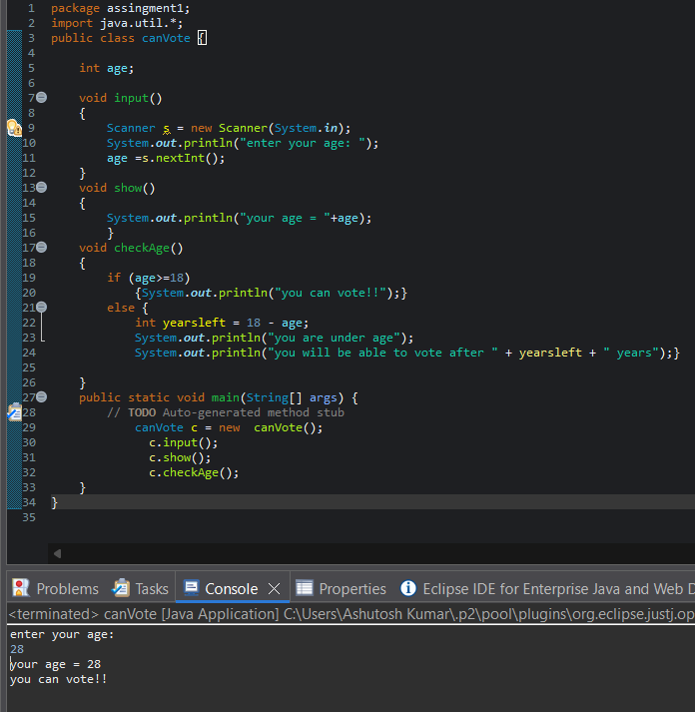

Q.3 Find the largest of two numbers entered by users.
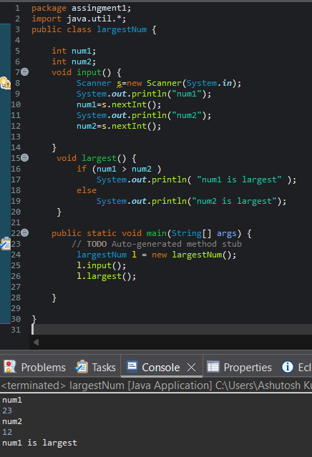

Q.4 User enters account balance and withdrawal amount. Check if withdrawal is possible.
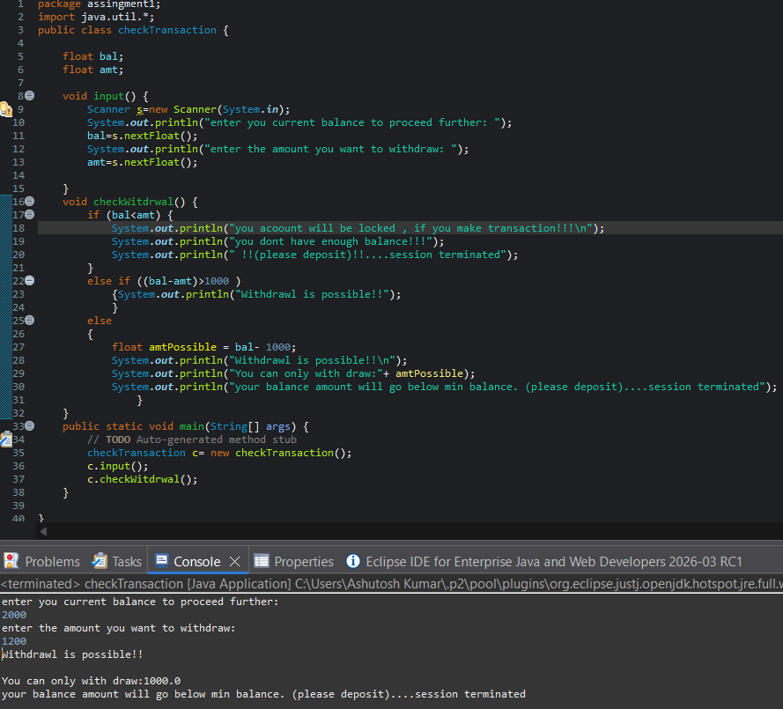

Q.5 check whether a given year is a leap year.
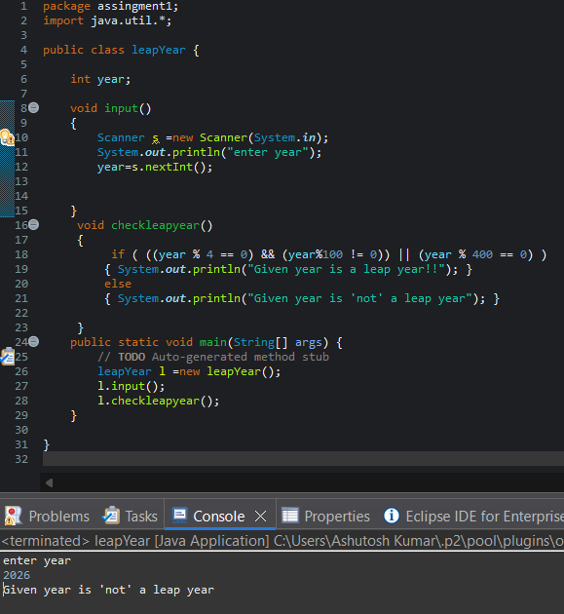

Q.6 Students marks are entered . display the grade based on the marks.
- 90 and above ->A
-75-89 ->B
-50-74 ->C
-below 50 -> D
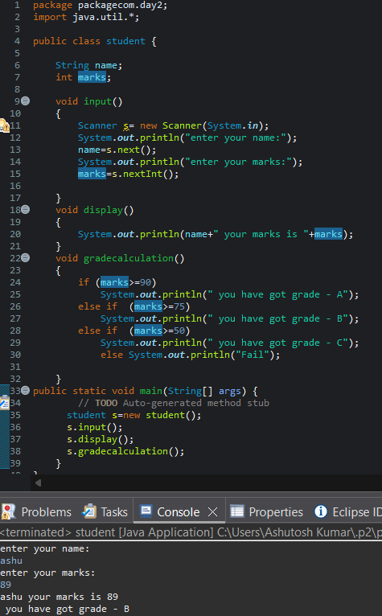
Q.7 An electricity board charges:
- First 100 units → ₹5 per unit
- Next 200 units → ₹7 per unit
- Above 300 units → ₹10 per unit
Write a Java program to calculate the total bill based on units consumed.
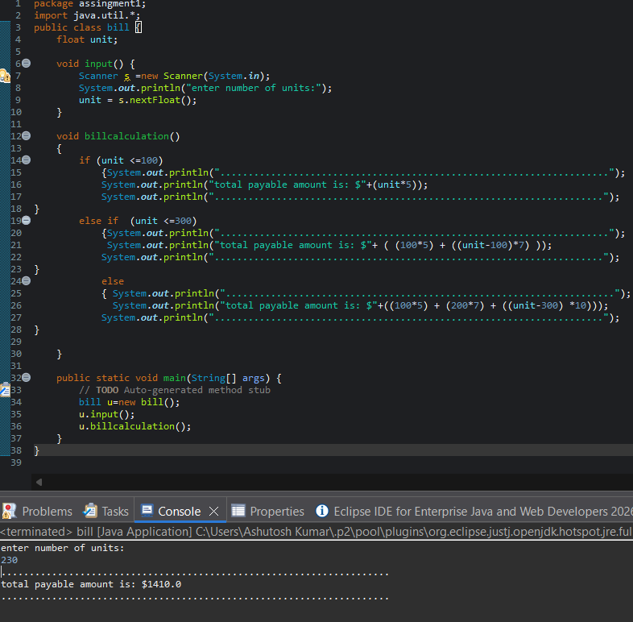

Q.8
A user must enter:
- Username: admin
- Password: 1234
Write a program to check login credentials and display:
- “Login Successful”
- “Invalid Username or Password”
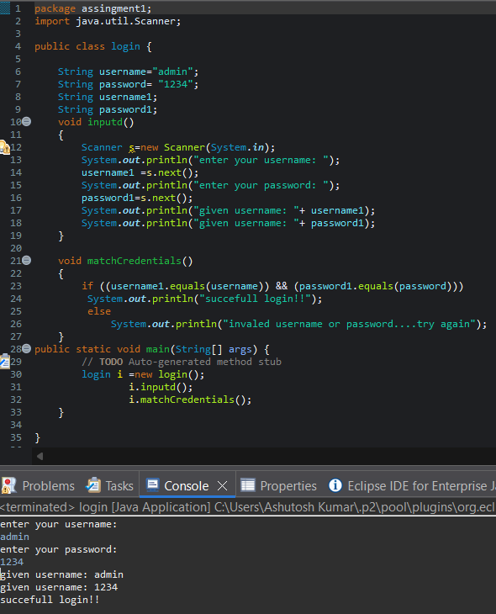
Q.9
A store gives discount based on purchase amount:
- Above ₹5000 → 20% discount
- ₹2000–₹5000 → 10% discount
- Below ₹2000 → No discount … Write a program to calculate final payable amount.
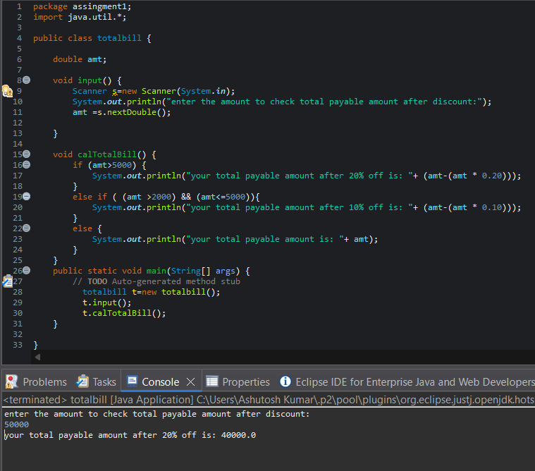

Q.10 Student must pass in all 3 subjects (marks ≥ 35).
If failed in any subject → “Fail”
If passed in all → “Pass”
Write a program to check result.
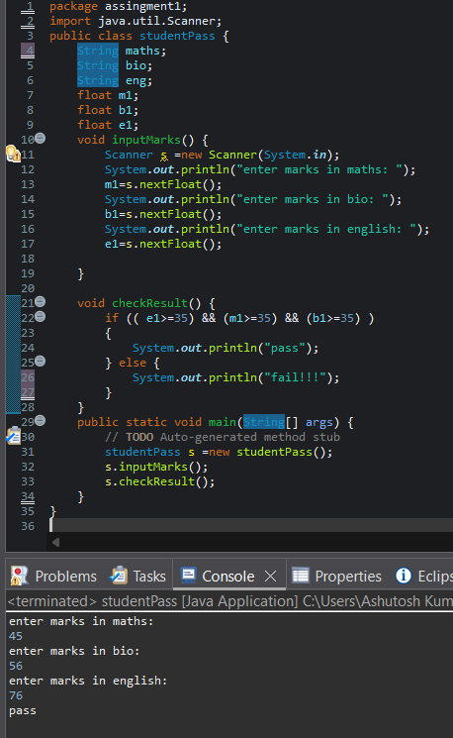

Q.11
Ticket price depends on age:
- Below 5 years → Free
- 5–18 years → ₹100
- 19–60 years → ₹200
- Above 60 years → ₹150 Write a program to calculate ticket price.
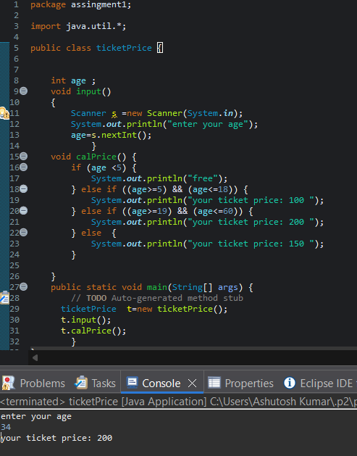

Q.12 If years of experience:
- Less than 2 years → No bonus
- 2–5 years → 10% bonus
- More than 5 years → 20% bonus .…… Write a program to calculate total salary after bonus.
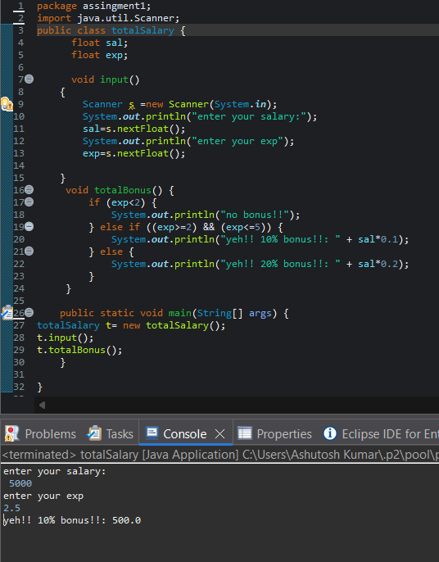

Q.13
User enters:
- PIN
- Balance
- Withdrawal amount
Conditions:
- PIN must match
- Withdrawal ≤ balance
- Minimum balance after withdrawal must be ₹1000
- Display proper message for each case.
